1. In previous lecture, we saw how to handle custom exception and how to send then custom error response.
2. 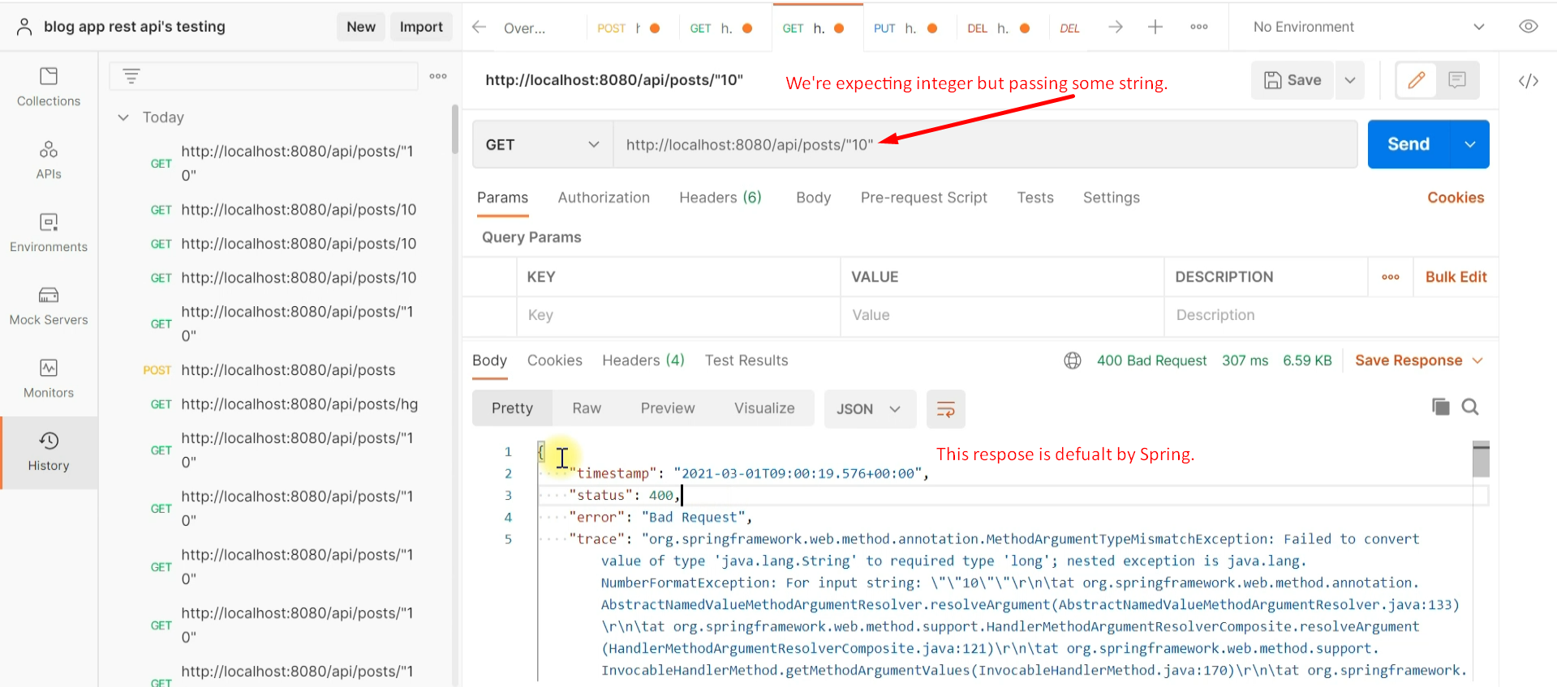
3. 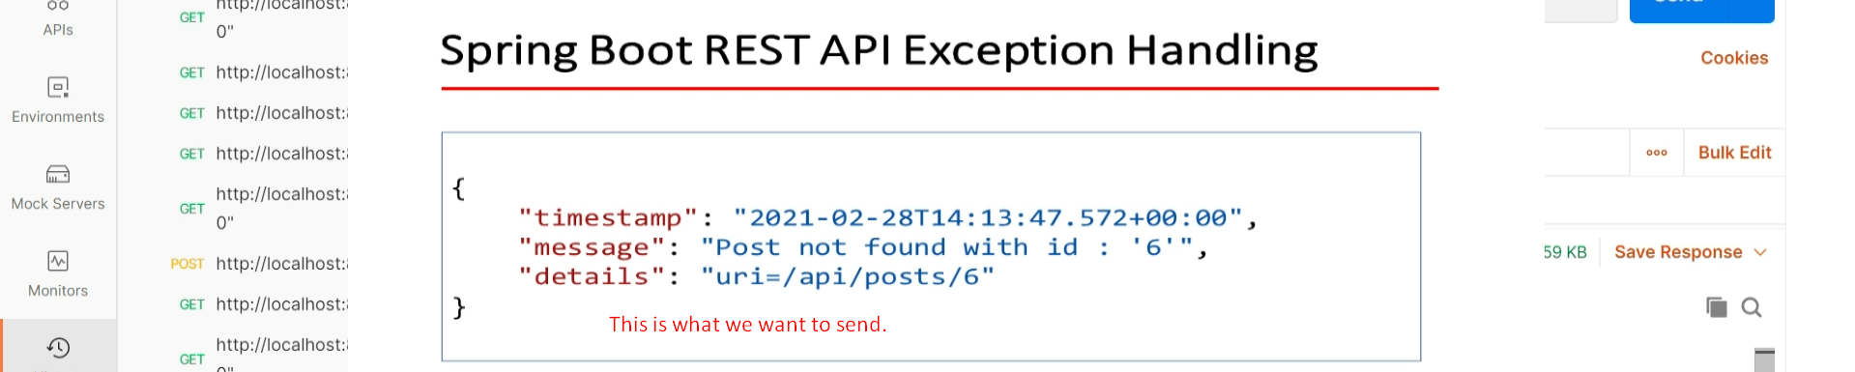
4. 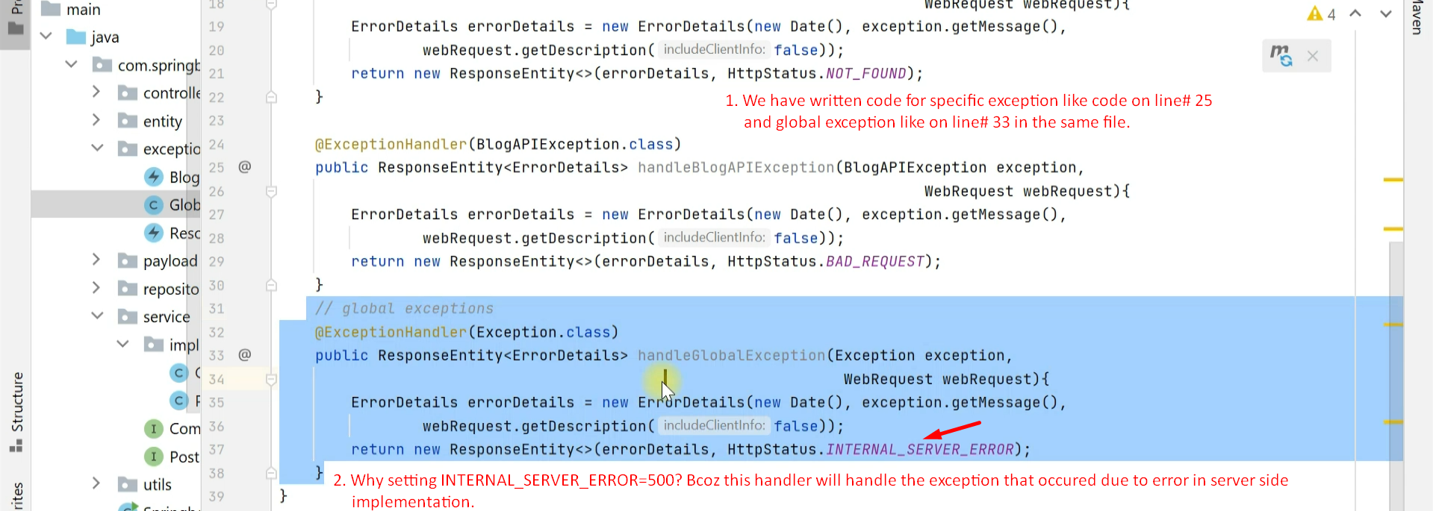
5. 